Session 20: SPARK STREAMING

Assignment 20.2

# **Problem Statement**

Read two streams

* List of strings input by user
* Real-time set of offensive words

Find the word count of the offensive words inputted by the user as per thereal-time set of offensive words.

**Step1**: Download the demonetization_tweets.csv from the Assignment Link given and copy to

/home/acadgild/assignment_20.2

**Step2**: Download AFINN.txt from the URL below

https://raw.githubusercontent.com/wendykan/twitter-sentiment-analysis/master/AFINN-111.txt

**Step3**: Process the tweets from demonetization-tweets.csv and store to temporary table tweets

* Create RDD from /home/acadgild/assignment_20.2/demonetization-tweets.csv and put to

tweets_rdd_with_header

* Filter the header from tweets_rdd_with_header and assign the RDD to tweets_rdd
* Filter the records based on field separator comma (,) and filter all the records who has numbers

of fields is greater than 2 and remove all quote characters, and map only first two fields and put

the result to tweets_filtered_rdd

* Create a dataframe with two fields id, words from tweets_filtered_rdd to
* Create a temporary tables tweets
* Explode words and create a table tweet_words

Scala code

* valtweets_rdd_with_header = sc.textFile("/home/acadgild/assignment_20.2/demonetizationtweets.csv")
* val header = tweets_rdd_with_header.first()
* valtweets_rdd = tweets_rdd_with_header.filter(row => row != header)
* valtweets_filtered_rdd = tweets_rdd.map(x =>x.split(",")).filter(x=>x.length>=2).map(x =>

(x(0).replaceAll("\"",""),x(1).replaceAll("\"","").toLowerCase)).map(x => (x._1, x._2.split(" ")))

* valtweets_df = tweets_filtered_rdd.toDF("id","words")
* tweets_df.registerTempTable("tweets")
* sqlContext.sql("select id as id,explode(words) as word from tweets").registerTempTable("tweet_word")

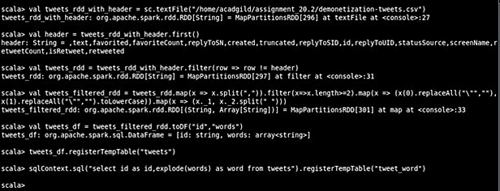

**Step4**: Process AFINN.txt and store to temporary table afinn

- Create RDD from ("/home/acadgild/AFINN.txt and put to afinn_rdd

- Split words of afinn_rdd based on tab and create a Dataframeafinn_df with fields word, rating

- Create temporary table afinn

* valafinn_rdd = sc.textFile("/home/acadgild/assignment_20.2/AFINN.txt")
* valafinn_df = afinn_rdd.map(x =>x.split("\t")).map(x => (x(0),x(1))).toDF("word","rating")
* afinn_df.registerTempTable("afinn")
* sqlContext.sql("select t.id,AVG(a.rating) as rating from tweet_wordt join afinna on t.word=a.wordgroup by t.id order by rating desc").show(100)

**Step5**: Find the the rating for tweet

sqlContext.sql("select t.id,AVG(a.rating) as rating from tweet_wordt join afinna on t.word=a.word

group by t.id order by rating desc").show(100)

